Parametric Functions – Teaching Set 1
Covering topics 2-3 – Plot/explain parametric equations and 2-4 – convert parametric to cartesian
1). [C] The point of this problem is for you to think about how the $x(t)$ horizontal movement combines with the $y(t)$ vertical movement, to create the path in the xy plane.
Consider the graphs of $x(t)$ and $y(t)$ describing movement along a path.
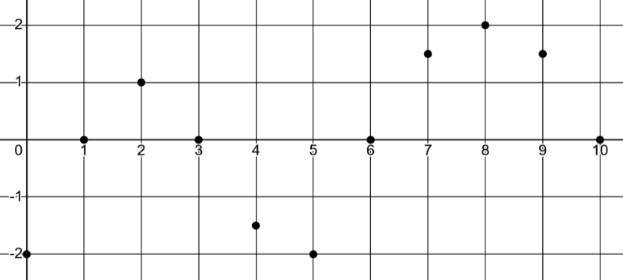
$$x(t)$$
This graph shows the horizontal movement
t

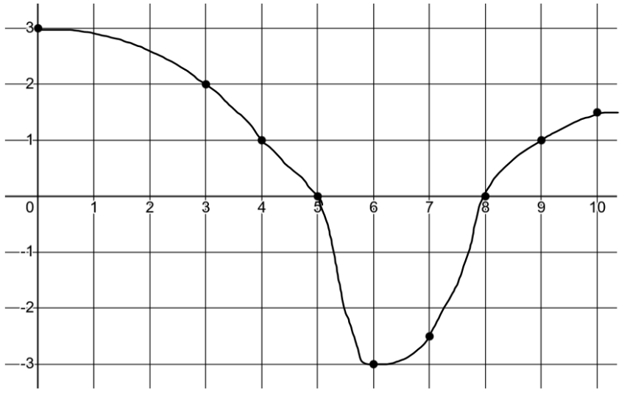
$$y(t)$$

This graph shows the vertical movement
t

All of these questions are about the path the moving point will follow in the xy plane. That path is not shown in these graphs. It’s what you would get if you combined the horizontal and vertical movements together.

- At time $t=0$ the (x, y) coordinates where the point starts are (-2, 3). How can you see that in the graphs?
- What’s the (x, y) location of the point at $t=5?$
- For what time intervals is the point moving left? (it could be diagonally left-up or left-down)
- When is it moving diagonal left-up? (what time interval?)
- At what time(s) does the point’s path cross the y-axis?
- What’s the domain and range for the graph of the path? (in other words, what x-values and y-values exist on the path if you were to plot all of them?)

2). [P/C] How can you tell the shape of the path being followed?
If you look at $x\left(t\right)=t^{2}$ you probably think “parabola!”. The point of this question is that you can’t know the shape of the path just by looking at what $x(t)$ is doing or $y(t)$ is doing separately.
If $x\left(t\right)=t^{2}$, the actual path the point moves along could be shaped like literally anything.
a). Consider the parametric equations: $x\left(t\right)=t^{2}$ and $y\left(t\right)=t^{2}$ on the interval $0≤t≤10$.
i). What do you think the path looks like?
Find the (x, y) coordinates at a few different times to give yourself an idea.

ii). Sketch the path.
Label $t=0$ and $t=10$ and draw arrows indication direction of movement.

iii). Why didn’t your path end up as a parabola?

iv). What if we change the time interval to $-10≤t≤10$ ?
What does the path look like now?
Check your guess: label the point at $t= -10$ in your path.
As time goes from -10 to 10, what’s the overall movement look like?

b). What if we have $x\left(t\right)=sin(t)$ and $y\left(t\right)=2⋅sin(t)$ on the interval $0≤x≤2π$?
Maybe this looks scary, but there’s a strong connection to the last problem.
a). Plug in some values for x that will be easy to calculate (like $\frac{π}{4}$ or $\frac{π}{2}$). Sketch the graph.
b). Compare and contrast this answer to problem #1.
Are the shapes of the path similar or not? How? Why?
Is the movement along the path similar or not? How? Why?
Is the domain/range of the overall path similar or not? How? Why?

3). [C/P] How could you find the equation for the path without plotting points?
Recall from the notes: I want to know the equation for the path described by $x\left(t\right)=10-t$ and $y\left(t\right)=t^{2}$
Solve the system by substitution to eliminate t.

$x=10-t$ $t=10-x$
$y=t^{2}$ $y={\left(10-x\right)}^{2}$

a. Let’s revisit the last two problems. For these you almost don’t need algebra at all.
i. If $x\left(t\right)=t^{2}$ and $y\left(t\right)=t^{2}$, why algebraically can you see that $x=y$ ?
ii. If $x\left(t\right)=sin⁡(t)$ and $y\left(t\right)=2\sin\left(t\right)$, why algebraically can you see that $y=2x$ ?

b. Try some that do require some algebra.
Find the cartesian equation for the path by solving the system.
i. If $x\left(t\right)=\frac{{\left(t-1\right)}^{3}}{3}$ and $y\left(t\right)=\frac{1}{t+2}+t$ use algebra to get the equation of the path.
ii. If $x\left(t\right)=2^{t}+1$ and $y\left(t\right)=\frac{1}{2^{t}}$ , use algebra to get the equation of the path.

4). [P] A trajectory is defined parametrically by the equations $\left\{ \begin{matrix}x\left(t\right)=\frac{1}{t+1} \\ y\left(t\right)=4t^{2}\end{matrix}\right.$ , where $0≤t≤3$
a). Plug in t = 0, 1, 2, and 3 to find the (x, y) coordinates along the path.
Graph the trajectory and label the initial and final points.
Show the direction of trace as t progresses with arrows.
b). Do you think there’s an asymptote in the (x, y) graph? Why or why not?
c). Let’s check. Eliminate the t variable to write a Cartesian equation representing a curve C such that the path travelled from $0≤t≤3$ lies on C.
d). Does the equation indicate there’s an asymptote? Where?

2-3. Plot and think about parametric paths – Teaching set 1 – Solutions
1). [C] Here are graphs showing the horizontal movement $x(t)$ and the vertical movement $y(t)$ for a moving point. I’ve also sketched the actual path through space in the xy plane the point moves along. This can be hard to imagine! The point of this problem is that you can read the original x(t) and y(t) graphs to answer questions about the movement.
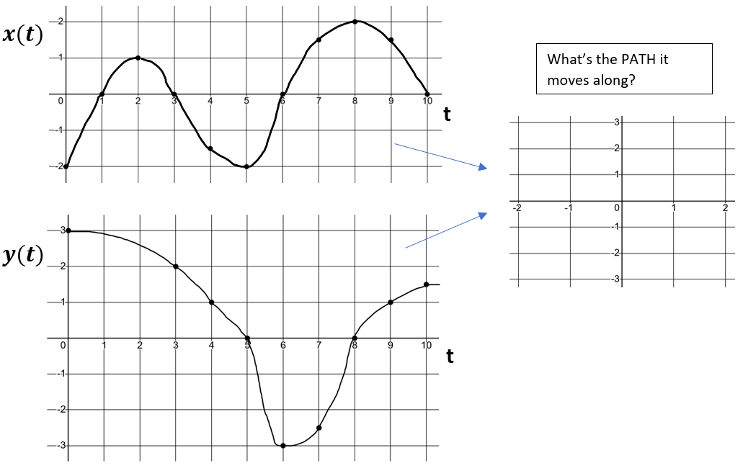

You weren’t supposed to sketch the motion, but here’s what it looks like if you were curious.
- At time $t=0$ the (x, y) coordinates where the point starts are (-2, 3). How can you see that in the graphs? Remember that the horizontal axis is time. So go to 0 on the horizontal axis, and look at the values in the vertical axis for each graph. You see $x\left(0\right)=-2$ and $y\left(0\right)=3$. That’s what at $t=0$ the point starts at $(-2,3)$.
- What’s the (x, y) location of the point at $t=5?$ At t = 5, the point is at (-2, 0)
- For what time intervals is the point moving left? (it could be diagonally left-up or left-down)
Moving left means the x-coordinate is decreasing. That seems to happen from $2≤t≤5$ and $8≤t≤10$
- When is it moving diagonal left-up? (what time interval?)
Diagonal left-up means x-coord is decreasing a y-coord is increasing. That happens from $8≤t≤10$ only.
- At what time(s) does the point’s path cross the y-axis?
Crossing the y-axis happens when an x-coordinates goes from positive to negative or vice versa. This happens at t = 1, 3, 6, and 10.
- What’s the domain and range for the graph of the path? (in other words, what x-values and y-values exist on the path if you were to plot all of them?)
The domain is all x-values for which the curve is defined. Here the min x-value is -2 and the max is 2, and we hit every x-value in between at some time. So: The domain would be $-2≤x≤2$. The range would be $-3≤y≤3$

2). [P/C] How can you tell the shape of the path being followed?
If you look at $x\left(t\right)=t^{2}$ you probably think “parabola!”. The point of this question is that you can’t know the shape of the path just by looking at what $x(t)$ is doing or $y(t)$ is doing separately.
If $x\left(t\right)=t^{2}$, the actual path the point moves along could be shaped like literally anything.
a). Consider the parametric equations: $x\left(t\right)=t^{2}$ and $y\left(t\right)=t^{2}$ on the interval $0≤t≤10$. What’s the shape of the path? Why is it not a parabola?
t | x(t) | y(t)
0 | 0 | 0
5 | 25 | 25
10 | 100 | 100

It’s not a parabola because at any time, we calculate x and y in the same way (square the time!), so the x and y coordinates are always that same. That’s just the line y = x. But, because time only ranges between 0 and 10, it’s only part of the line $y=x$. The domain is restricted to be 0 to 100.

iv). What if we change the time interval to $-10≤t≤10$ ?

$$t=-10$$
$$t=0$$
$$t=5$$
$$t=-5$$
$$t=10$$
The overall path didn’t change at all, but the movement along the path does.

At $t=-10$ the point starts in the upper right at (100, 100) and then moves left until it gets to (0, 0) at $t=0$. Then it moves right again until it gets back to (100, 100) at $t=10$.

You may notice that isn’t $t=5$ half-way along the path. Why is that? (you think about this one).
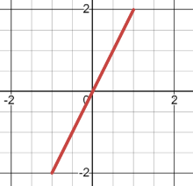
$$t=0$$
$$t=\frac{π}{2}$$
$$t=π$$
$$t=\frac{3π}{2}$$
b). What if we have $x\left(t\right)=sin(t)$ and $y\left(t\right)=2⋅sin(t)$ on the interval $0≤x≤2π$?
b). Compare and contrast this answer to problem #1.
Are the shapes of the path similar or not? How? Why?
Is the movement along the path similar or not? How? Why?
Is the domain/range of the overall path similar or not? How? Why?
You don’t need to make a graph to “see” this, but it might help if you’re just starting out. $⋅2$
t | $$x\left(t\right)=sin⁡(t)$$ | $$y\left(t\right)=2sin⁡(t)$$
$$0$$ | 0 | 0
$$\frac{π}{2}$$ | 1 | 2
$$π$$ | 0 | 0
$$\frac{3π}{2}$$ | -1 | -2
$$2π$$ | 0 | 0

The graph is the line $y=2x$ on $-1≤x≤1$
Notice that x is $sin⁡(t)$ and y is $2⋅sin⁡(t)$. But that’s just 2 time the x-value.

Things to notice:
Why is it a line? | Because the y-value is always twice the x-value. Think about plugging in any value for t. The x-value is sin(t) (which is some number), but the y-value will be twice that. So the x, y values have a linear relationship to each other.
Why is the slope 2? | In the previous problem, the x and y values were the same. If x goes up by 1, y goes up by 1, which is what a slope of 1 means. Here, the y-values are twice the x value. If x goes up by 1, y goes up by 2, which is a slope of 2.
Why is there a domain restriction? | Since $x\left(t\right)=sin⁡(t)$ the x values can’t be larger than 1 or smaller than -1, since those are the largest and smallest values that sine can output.
What is the motion doing? | BOUNCING! As time increases, the output from sine oscillates between -1 and 1, which means our point will also oscillate back and forth along this line. Keen!

A key take-away here is that you won’t see the relationship if you’re focused on what numbers you get for x. You can’t look at $\sin\left(t\right)$ and think “what number will I get?”. You have to look at $\sin\left(t\right)$ and think: “that’s some number that represents the x-coordinate”.
That lets you look at $y\left(t\right)=2⋅sin⁡(t)$ and think: “ah! that’s $y\left(t\right)=2⋅\left(the x coordiante\right)$”.

3). [C/P] How could you find the equation for the path without plotting points?
a. Let’s revisit the last two problems. For these you almost don’t need algebra at all.
i. If $x\left(t\right)=t^{2}$ and $y\left(t\right)=t^{2}$, why algebraically can you see that $x=y$ ?
ii. If $x\left(t\right)=sin⁡(t)$ and $y\left(t\right)=2\sin\left(t\right)$, why algebraically can you see that $y=2x$ ?
Use the blob technique: think about what the blob represents.
$x\left(t\right)=t^{2}$ and $y\left(t\right)=t^{2}$ So: $y\left(t\right)=x(t)$ which is just another way to write $y=x$

$x\left(t\right)=sin⁡(t)$ and $y\left(t\right)=2\sin\left(t\right)$ So: $y\left(t\right)=2⋅x(t)$. Which is $y=2x$.

b. Try some that do require some algebra. Find the cartesian equation for the path.
i. If $x\left(t\right)=\frac{{\left(t-1\right)}^{3}}{3}$ and $y\left(t\right)=\frac{1}{t+2}+t$ use algebra to get the equation of the path.
I can isolate t in the $x(t)$ equation:
$3x={\left(t-1\right)}^{3}$ $\sqrt[3]{3x}=t-1$ $\sqrt[3]{3x}+1=t$ Now we can plug that into the $y(t)$ equation

$$y\left(t\right)=\frac{1}{t+2}+t = \frac{1}{\sqrt[3]{3x}+1 +2} + \sqrt[3]{3x}+1 = \frac{1}{\sqrt[3]{3x}+3} + \sqrt[3]{3x}+1$$
ii. If $x\left(t\right)=2^{t}+1$ and $y\left(t\right)=\frac{1}{2^{t}}$ , use algebra to get the equation of the path.
You could try to isolate t. That would look like this…
$x=2^{t}+1$ $x-1=2^{t}$ $\log_{2}\left(x-1\right)=t$
Then you can substitute:
$y\left(t\right)=\frac{1}{2^{t}}$ $y\left(t\right)=\frac{1}{2^{\log_{2}{(x - 1)}}}$ which simplifies as $y\left(t\right)=\frac{1}{x-1}$
Here’s a better way. Notice that $2^{t}$ appears in both equations.
$x\left(t\right)=2^{t}+1$ and $y\left(t\right)=\frac{1}{2^{t}}$
That means you just have to isolate $2^{t}$ and you can substitute.
$x=2^{t}+1$ $x-1=2^{t}$ Now substitute! $y=\frac{1}{2^{t}}$ $y=\frac{1}{x-1}$

4). [P] A trajectory is defined parametrically by the equations $\left\{ \begin{matrix}x\left(t\right)=\frac{1}{t+1} \\ y\left(t\right)=4t^{2}\end{matrix}\right.$ , where $0≤t≤3$
a). Plug in t = 0, 1, 2, and 3 to find the (x, y) coordinates along the path.
Graph the trajectory and label the initial and final points.
Show the direction of trace as t progresses with arrows.
T | X(t) | Y(t)
0 | 1 | 0
1 | 1/2 | 4
2 | 1/3 | 16
3 | ¼ | 36

b). Do you think there’s an asymptote in the (x, y) graph? Hard to say just by looking at the graph. Maybe it’s more like a parabola in which case there’s no vertical asymptote. But maybe it’s more like $\frac{1}{x}$ in which case there would be. Let’s look at the equation.
I can isolate t in $x\left(t\right)=\frac{1}{t+1}$ $x\left(t+1\right)=1$ $xt+x=1$ $xt=1-x$ $t=\frac{1-x}{x}$ . Substitute this into $y(t)=4t^{2}$ giving: $y=4{\left(\frac{1-x}{x}\right)}^{2}$
It looks like there is a vertical asymptote at x = 0.
One way to see it is simplifying the inside: $y=4{\left(\frac{1}{x}-1\right)}^{2}$ . Now you can clearly see that $\frac{1}{x}$ bit.

